Algebra II/Trig Name: ____________________
Chap 13 RETAKE ASSIGNMENT
Block: __________

1) Evaluate the six trigonometric functions of θ.

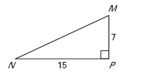

2) Complete the following chart:

 | 0˚ | 30˚ | 225˚ | 300˚ | 270˚
sin θ
cos θ
tan θ
cot θ
sec θ
csc θ
3) Given sin θ=2/5, find cot θ, sec θ, and csc θ.

4) CSC is the reciprocal of what trig function?

____________________

5) The cos 90˚ is equal to _______________ of 0˚.

6) Convert the following to radians.

225˚=__________

42˚=__________

7) Convert the following to degrees.

8) Drawr the following angles (include the spiral and terminal ray.)

a. 325˚

b. -260˚

c.

9) Find 2 positive and negative coterminal angles for each given angle.

a.

b.

10) Given the point (-4-2), find the sine, cosine, and tangent of the reference angle created by the terminal ray.

11) Evaluate the following trig functions. Use exact values and show your work.

a.

b.

c.

d.

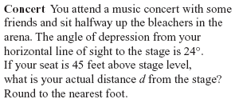
12)

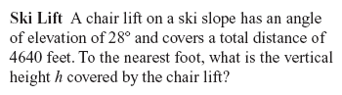
13)

14) Solve. All answers should be in general solutions.

a.)

x=____________________

b.)

x=____________________

c.)

x=____________________

d.)

x=____________________

e.) sinx + sinx cosx = 0

x=____________________

f.)

x=____________________
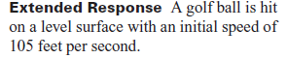
15.)

